**Technology factor**

**Material and Human resource**

The biggest thing that impede the built out of a strong charging station network is high cost of equipment and installation. The main categories of charging station can be listed as; actual charging station hardware; other hardware and materials; electrician and other labor; mobilization; and permitting. You can see the shares of these categories on figures below. [1]

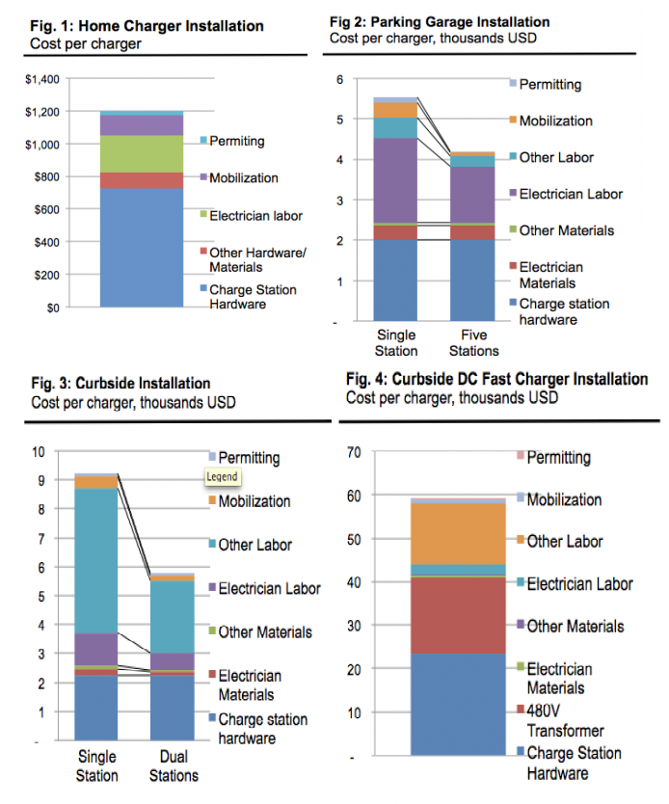

As it is seen hardware costs and labor costs are biggest part of total cost of charging station. Hardware costs need to be decreased especially fast DC charging station. It is very important especially charging speed is considered. Highly skilled labor cost is also important in human resource perspective.

**EVs battery**

In most broad perspective, sustainable energy is not just inevitable need for our future but also more economic and profitable for long run. EVs are subtopic of this broad subject. We need not just cheaper EVs to run, but also cheaper EVs to purchase. Cost of EV battery covers the biggest part of total manufacturing cost of EV.

“*In 2010, battery professor Poul Norby stated that he believed that lithium batteries will need to double their energy density and bring down the price from $500 (2010) to $100 per*[*kWh*](http://en.wikipedia.org/wiki/KWh)*capacity in order to make an impact on gasoline cars.*[*Citigroup*](http://en.wikipedia.org/wiki/Citigroup)*indicates $230/kWh. As of October 2014, the cost of Tesla batteries is $180/kWh*.”[2] Prices get down more rapidly than expected because of mainly market leaders Tesla and Nissan with cost decreasing 8% per annum.

Table http://en.wikipedia.org/wiki/Electric_vehicle_battery#Battery_cost

**Charging speed**

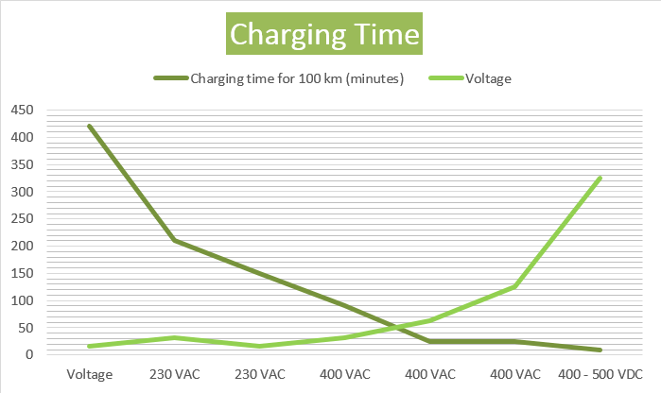Charging speed is the key factor for EVs market. It becomes better every new technological advancements in charging stations. Yet, fast DC chargers are very expensive at present. Latest EVs battery capacities are good enough compared with desired all-electric range according to researches. (Look at California case study) Only disadvantage of EVs in this case is charging speed in the case of present technology. When fast DC charging network become as advanced as gasoline station network, EVs can have same travel range (When most advanced EVs battery electric range at present considered) and refueling/charging capabilities. When wireless and swapping technology considered in same way, charging of EVs can be more advanced compared with gasoline vehicles in all cases.

Table http://en.wikipedia.org/wiki/Electric_vehicle_battery#Battery_cost

**Maintenance**

Maintenance of EVs chargers is part of EVs maintenance in most cases of producers. Modern gasoline cars involves high number of big and small parts and this situation getting worse due to vehicles’ increasing complexity. This situation attracts high cost of labor for maintenance. Electric vehicles are no exception to this problem; however, they are still much cheaper to maintain due to their inherent simplicity.[3] Maintenance of charging stations requires diverse process according to type of station

**Payment system and Price**

**Blockchain technology**

**cost of charging station**

1. <http://blog.rmi.org/blog_2014_04_29_pulling_back_the_veil_on_ev_charging_station_costs>
2. <http://ing.dk/artikel/et-batteri-til-en-elbil-koster-60000-kroner-109887>
3. <http://cleantechnica.com/2012/12/18/ev-maintenance-much-cheaper-than-that-of-ice-vehicles/>

   <http://en.wikipedia.org/wiki/Electric_vehicle_battery#Battery_cost>

   <http://ing.dk/artikel/et-batteri-til-en-elbil-koster-60000-kroner-109887>

   <http://cleantechnica.com/2014/10/13/battery-costs-may-drop-100kwh/>

   <http://www.treehugger.com/cars/electric-car-batteries-track-drop-price-70-2015-says-energy-secretary.html>